**Problem Statement**

Goal of this project is use googles trained mobile net v2 model which is trained on 1.5 million images and total 1000 classes, to identify the type of flower.

**Architecture**

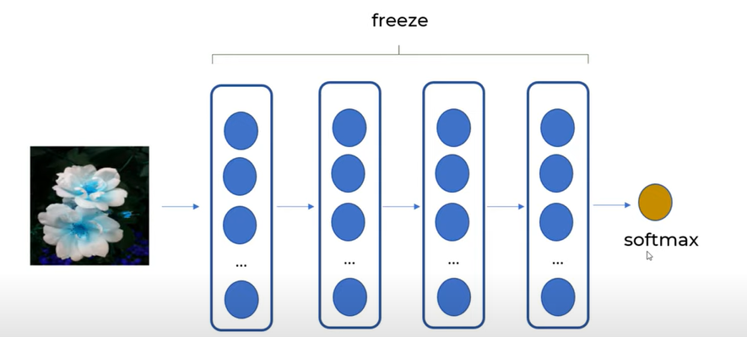

**Data Details**

1. We would be identifying 5 flower types based on input image provided

* Daisy
* Tulip
* Rose
* Dandelion
* Sunflower

**Code to Refer**